* **The Impact of Gameplay Mechanics in 3D related industry**

**Advanced Gameplay Survival Mechanics for Multiplayer in Unreal Engine**

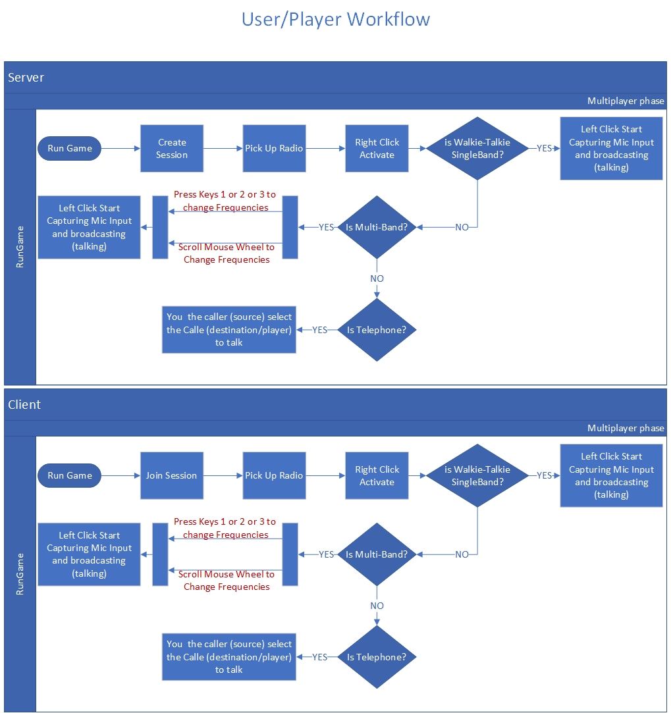

**Gameplay Mechanics**

**XR**

* Survival horror genre experience T/FPP
* Actor in-place Animations / Locomotion’s
* Character Mannequin / Body appearance
* Survival Gear for a ghost hunt
* Diary – Quest/events System
* Inventory
* Save System
* Inspection System
* Footstep Sound System
* NPC hunt mode
* Network Replicated / Multiplayer Ready
* VoIP
* Any many much more ..

Michail Markou

**VR**

**AR**

**MR**

$$⊃$$

Server Client Communication Model

**User/Player Flowchart**

SUMMARY

RESULTS

METHODOLOGY

ABSTRACT

The digital world is a highly engaging product that tends to retain its users throughout its narrative or objective. At the core of its application, from business objectives to product delivery, are video game systems. The research focuses on the demographic data, preferences of virtual worlds as well as their riveting experience, comparing it with corresponding titles of commercial success in the super. and the cons. The development system of the present work is focused on multiplayer survival horror experience such as environmental player interactions and real time communications (Voice over IP - VOIP) as well as the architecture of their creation systems programmatically but also from other contributing aspects such as 3D Architectural Visualization, Sound Design. The techniques given are abstracted and can contribute as a concept for any kind of genre game (*virtual world*) mechanic but also in any kind of AR / VR & metaverse platform.

1. Finding and satisfying the requirements of the top trend Feature via Survey

2. Selection of tools / technologies implementations of the requirements

3. Select Project Management & software development methodologies (Plural because i.e., and / or agile + DevOps)

4. UML & Class Design

5. Level Blocking out / white Boxing

6. Class implementation

7. Testing (QA) + logging

8. 3D modeling, Animation & material authoring

9. Finalize results

10. Deploy & Production

11. Support & Q&A

Metaverse

* Department of Computer Science - UEL